

**MILESTONE 2 COMPLIANCE REPORT**

**Design of the necessary infrastructure for researchers**

***Refereed scientific journal specialized in studies of the Blockchain ecosystem***

**MAY, 2024**

Contents

INTRODUCTION 5

This report is related to the second milestone of the project. It is shows the process and expected results in the milestone that contributes to the development and consolidation of the project. This second milestone of the project corresponds to what was established and approved by Catalyst that was established in the period from April to June, but the times were adjusted to be delivered to the month of May of this year. This document presents proof of the completed achievements established in milestone to account for the documents and photographic and video evidence of the completed and operational development. 5

TECHNOLOGICAL INFRASTRUCTURE ARCHITECTURE 6

Virtual Private Server (VPS) 6

Advantages of VPS hosting 6

What features does VPS hosting have? 6

Principal functions: 7

• Data Storage: 7

• Data processing: 7

• Data Distribution: 7

Dedicated hosting 7

The proposal has: 8

• Resource and space management: 8

Security and data protection 8

Determination and acquisition of the necessary requirements for the development and protection architecture of the technological platform in VPS: 9

Design Approach 9

Functional requirements and implemented for systems development environment 11

WEB PORTAL OF THE REFEREEED SCIENTIFIC JOURNAL "INTEROPERABILIDAD” 12

Design of the interface of the web portal of the peer-reviewed scientific journal "Interoperabilidad", which must be attractive and easy to navigate for users. 12

Frontend Design Web portal of the peer-reviewed scientific journal "Interoperabilidad" 13

Establishment of the content management system (CMS), for the development of the journal and the lines of research necessary for the Researchers. 13

The portal must have clear policies on editorial ethics, conflicts of interest, copyright, among other aspects. Relevant to publications. 13

Indexing the scientific database to increase the visibility and impact of the scientific journal. 13

Ongoing technical support to ensure the correct functioning of the portal and resolve any technical problems that may arise. 14

RESULT OF THE WEB PORTAL OF THE INTEROPERABILITY SCIENTIFIC JOURNAL 15

Main Page of the Scientific Journal “INTEROPERABILIDAD” 15

Publication Standards 16

Contacts 17

Check in 18

Log in 19

# INTRODUCTION

# This report is related to the second milestone of the project. It is shows the process and expected results in the milestone that contributes to the development and consolidation of the project. This second milestone of the project corresponds to what was established and approved by Catalyst that was established in the period from April to June, but the times were adjusted to be delivered to the month of May of this year. This document presents proof of the completed achievements established in milestone to account for the documents and photographic and video evidence of the completed and operational development.

# TECHNOLOGICAL INFRASTRUCTURE ARCHITECTURE

The architecture of the technological infrastructure was developed and implemented according to the planning and requirements that was presented by Engineers David Jaen and Nando Viti who were in charge of executing the installation and fine-tuning of the a virtual private server (VPS), which is a machine that hosts all the software and data necessary to run an application or a website that in this project will be necessary for the hosting and functionality of the web portal of the Arbitrated Scientific Journal INTEROPERABILIDA.

## Virtual Private Server (VPS)

A virtual private server (VPS) is a machine that hosts all the software and data needed to run an application or website. It is called virtual because it only consumes a portion of the server's underlying physical resources, managed by a third-party provider.

## Advantages of VPS hosting

1. Dedicated server space.
2. Fast and reliable.
3. Allows a large number of users to access your website without problems.
4. You can customize the server according to your needs.
5. Easily scalable, you can improve resources as your site grows.

## What features does VPS hosting have?

|  |  |
| --- | --- |
| **Description** | **Features** |
| **Domains** | **UNLIMITED** |
| **Sub Domains** | **UNLIMITED** |
| **Email Accounts.** | **UNLIMITED** |
| **MySQL databases** | **-------------------------------------------------** |
| **Weekly Automated Backups** | **-------------------------------------------------** |
| **FTP Accounts** | **UNLIMITED** |
| **Private DNS Servers** | **-------------------------------------------------** |

## Principal functions:

* Data Storage: Your responsibility is to store volumes of data, from individual files to entire databases. They use storage and redundancy systems to guarantee the integrity and availability of information.
* Data processing: There are servers and processing equipment that are responsible for carrying out complex operations and calculations in real time. This allows applications and services to run efficiently and quickly.
* Data Distribution: DCs are also responsible for data distribution over networks. They facilitate access to information from different locations, allowing users to access services

and content quickly and without interruptions.

## Dedicated hosting

With dedicated hosting, you rent an entire physical server for your business. If you have a high-traffic website, dedicated hosting may be the best solution for you, as dedicated servers are fast, flexible, and fully customizable. However, the service also comes with a price, so it is not the best solution for everyone, especially if you have a small or medium-sized website.

While VPS hosting allows you to choose and configure your operating system and server applications, dedicated hosting goes a step further. It not only allows you to configure the software but also the hardware, since the entire server is yours and no one has a say in the configuration. You can also run a dedicated server on-site (e.g. in your office), however, you won't get the support of a professional hosting team in that case.

In the project and for the development and implementation of the Interoperability Scientific Magazine Portal, it was decided to select this type of hosting.

## The proposal has:

* Resource and space management: There is space in the servers and there is virtual service for growth (scalability and growth capacity).
* **Quality management**

The NTC_ISO 9001:2008 standard will be reviewed and additionally applied for the documentation of the CD, user manual and functions.

## Security and data protection

* **Physical security measures:**

Physical security is a critical aspect in administration. Measures such as access control systems, video surveillance, fire protection and power backup systems are implemented to ensure the integrity and continuity of operations. In addition, strict protocols are established for physical access to the data center and the protection of equipment and infrastructure.

* **Protection against cyber attacks:**

Data protection and cybersecurity are constant challenges in administration. Robust security measures, such as firewalls, intrusion detection systems and data encryption, must be implemented to protect stored information and prevent cyber attacks. Constant monitoring and application of security updates are essential to mitigate risks and ensure data privacy and confidentiality.

## Determination and acquisition of the necessary requirements for the development and protection architecture of the technological platform in VPS:

|  |  |
| --- | --- |
| **Suggested equipment** | **Description** |
| **Virtual Private Server (VPS) Contracted Service** | 1. Processing Speed 1 x 2GHz CPU 2. Best RAM Memory 1 GB RAM 3. Fast Storage 30GB SSD 4. Bandwidth 100mbps 5. Dirección IP Dedicada 1 IP 6. Business Email Accounts 3 Mailboxes + Unlimited Aliases |
| **Environments** | For development, production and quality environments, the characteristics of the VPS are sufficient at this first moment. |

## Design Approach

The development of the project will be carried out using virtual machines created on a physical server. The virtual machines are:

- Application Server

- Internal Domain Server (DNS)

- Repository Service

- Backup Server

A server is a computer on which your web host stores the files and databases necessary for your website. Every time an online visitor wants to access your website, their browser sends a request to your server and transfers the necessary files over the Internet.

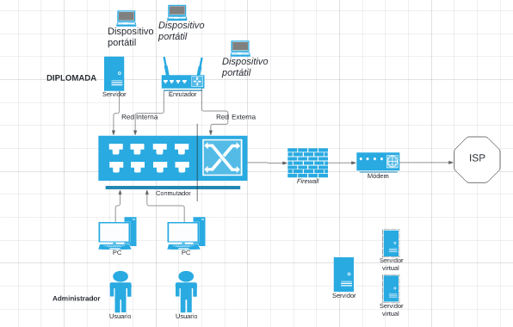

Fig.1 Functional scheme

VPS hosting provides you with a cloud server that simulates a physical server, but the machine is shared between multiple users.

Using virtualization technology, your web hosting provider installs a virtual layer on top of the server's operating system (OS). This layer divides the server into partitions and allows each user to install their own operating system and software.

Therefore, a virtual private server (VPS) is both virtual and private because you have complete control. It is separated from other users of the server at the operating system level. In fact, VPS technology is similar to creating partitions on your computer when you want to run multiple operating systems (for example, Windows and Linux) without having to reboot.

A VPS allows you to set up your website inside a secure container with guaranteed resources (memory, disk space, CPU cores, etc.) that you don't have to share with other users. With VPS hosting, you have the same root-level access as renting a dedicated server, but at a much lower cost.

## Functional requirements and implemented for systems development environment

This report describes the tools and requirements necessary to build the development, testing and production environment of the web systems that are currently under development.

The requirements for the environment are the following:

* Operating system based on free software based on DEBIAN (Debian Server, Ubuntu Server, CentOS)
* Apache application server in its version (2.4)
* Install PHP in its most recent version (8.3)
* Install the COMPOSER dependency manager globally.
* Install npm in its latest version and the NodeJS dependency manager in version 20.12.
* install the database administrator, MySql in version 8.30
* Install the Postgresql database administrator in version 16.2

All architectural requirements for the portal are enabled and implemented to support the Interoperability Scientific Magazine portal.

# WEB PORTAL OF THE REFEREEED SCIENTIFIC JOURNAL "INTEROPERABILIDAD”

The next point describes the process and execution in the development of the Scientific Magazine web portal, as follows:

## Design of the interface of the web portal of the peer-reviewed scientific journal "Interoperabilidad", which must be attractive and easy to navigate for users.

Reference is made to the structure and visual organization of the elements on a screen (buttons, menus, forms), etc.

Focuses on the user experience and how they interact with the application.

Focuses on the appearance and usability of visual elements, based on the following elements:

1. Logo of the scientific journal
2. Navigation menu with sections such as: Home, About the magazine, Rules for authors, Latest issues, Contact
3. Article search section by title, author or keyword
4. Promotional banner with information about upcoming calls and events related to the magazine
5. News and developments section in the scientific field
6. Contact form for questions and suggestions
7. Links to social networks to share content and follow the scientific journal
8. Scientific journal subscription section to receive notifications about new issues and published articles
9. Access to databases and resources related to the topic of the scientific journal

10.Gallery of images related to the articles published in the scientific journal

## Frontend Design Web portal of the peer-reviewed scientific journal "Interoperabilidad"

Reference is made to the implementation of this interface in code, using technologies such as HTML, CSS and JavaScript among others, agreed upon by the operational team.

It focuses on the technical implementation of those elements so that they work correctly on the website or application.

## Establishment of the content management system (CMS), for the development of the journal and the lines of research necessary for the Researchers.

It is necessary to have a system that allows the efficient management of scientific articles, their peer review, their publication and their indexing in scientific databases.

## The portal must have clear policies on editorial ethics, conflicts of interest, copyright, among other aspects. Relevant to publications.

It must have clear and transparent policies, guided by the base document and the regulations of the journal.

## Indexing the scientific database to increase the visibility and impact of the scientific journal.

It is important that the articles are indexed in internationally recognized scientific databases.

Allows you to increase the visibility and impact of the magazine

## Ongoing technical support to ensure the correct functioning of the portal and resolve any technical problems that may arise.

It is essential to have a technical team that provides continuous support to ensure the correct functioning of the portal and resolve any technical problems that may arise.

**Launch of the web portal of the peer-reviewed scientific journal "Interoperabilidad"**

A set of tests necessary for the launch of said portal must be carried out.

# RESULT OF THE WEB PORTAL OF THE INTEROPERABILITY SCIENTIFIC JOURNAL

Below are images and explanation of the portal already developed and in testing as proposed in milestone number 2. The following pages provide support for the achievement achieved in the development and implementation of the aforementioned portal.

## Main Page of the Scientific Journal “INTEROPERABILIDAD”

In this page show the functionalities that are developed and functional where the user can navigate in order to be able to make their information requirements, register or start the session. Here the user can read the information about what it is and the objective of the magazine

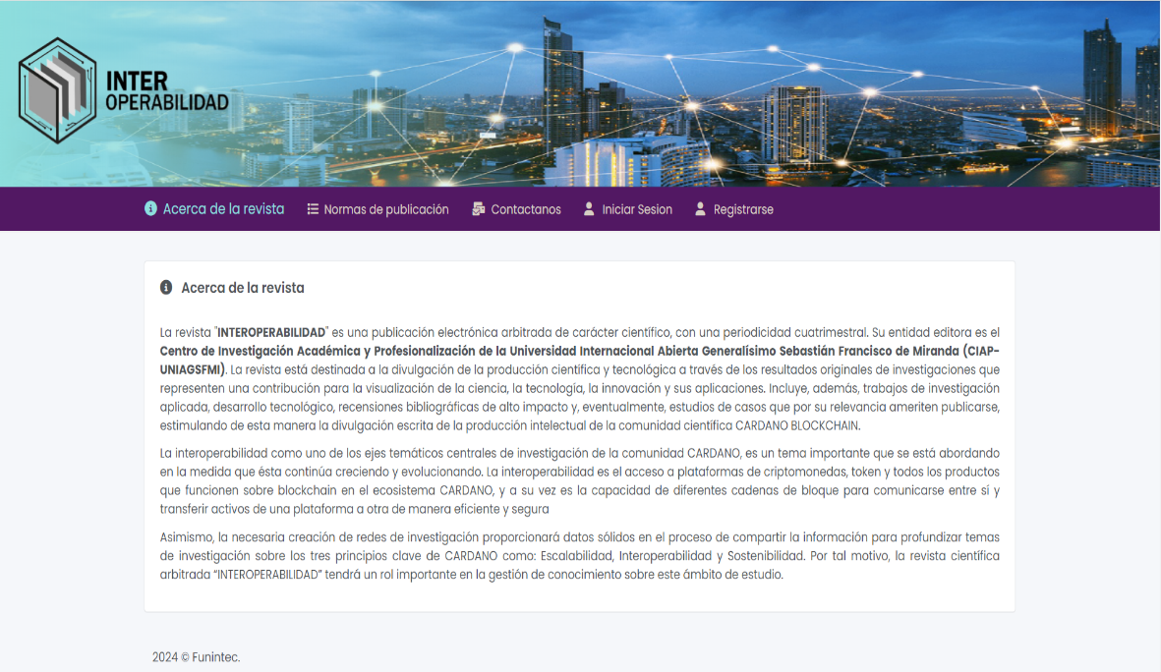

The buttons that can be seen for navigation are the following:

* About the Scientific Journal
* Publication Standards
* Contacts
* Log in
* Check in

## Publication Standards

Inthis section the user can read the publication rules and responsibilities as well as the necessary requirements to be able to use the services of the scientific journal.

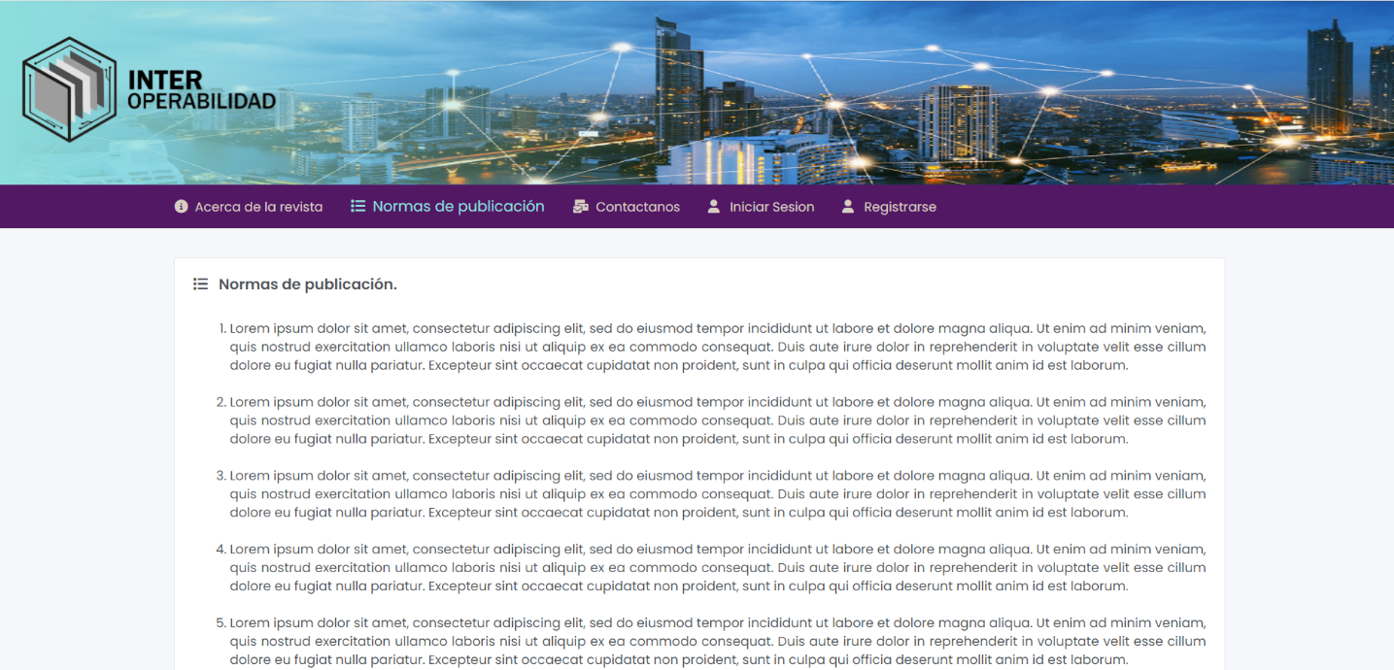

## Contacts

In this section the user will be able to have contact information and physical location of the institution's offices.In this section the user will be able to have contact information and physical location of the institution's offices.

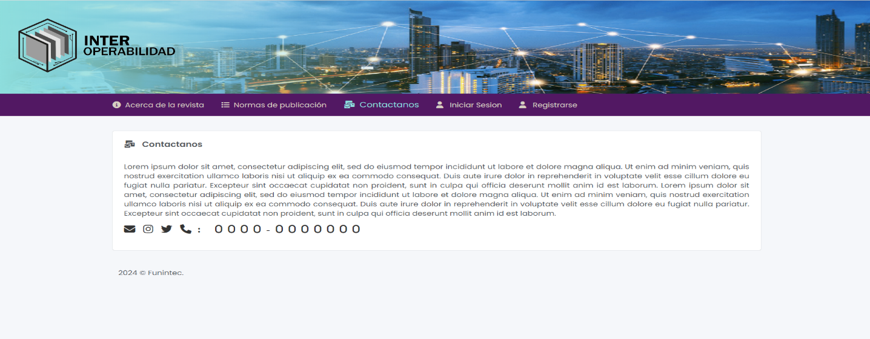

## Check in

The person who registers in the Scientific Journal system does so through this means and must enter the requested information. Once registered, your user is the reader of the documents and other information that will be uploaded to the platform and the blockchain.

Once the person is registered, they can go from being a reader to being a columnist once they pass the necessary requirements to become one. So it can have both characteristics if the new user so desires.

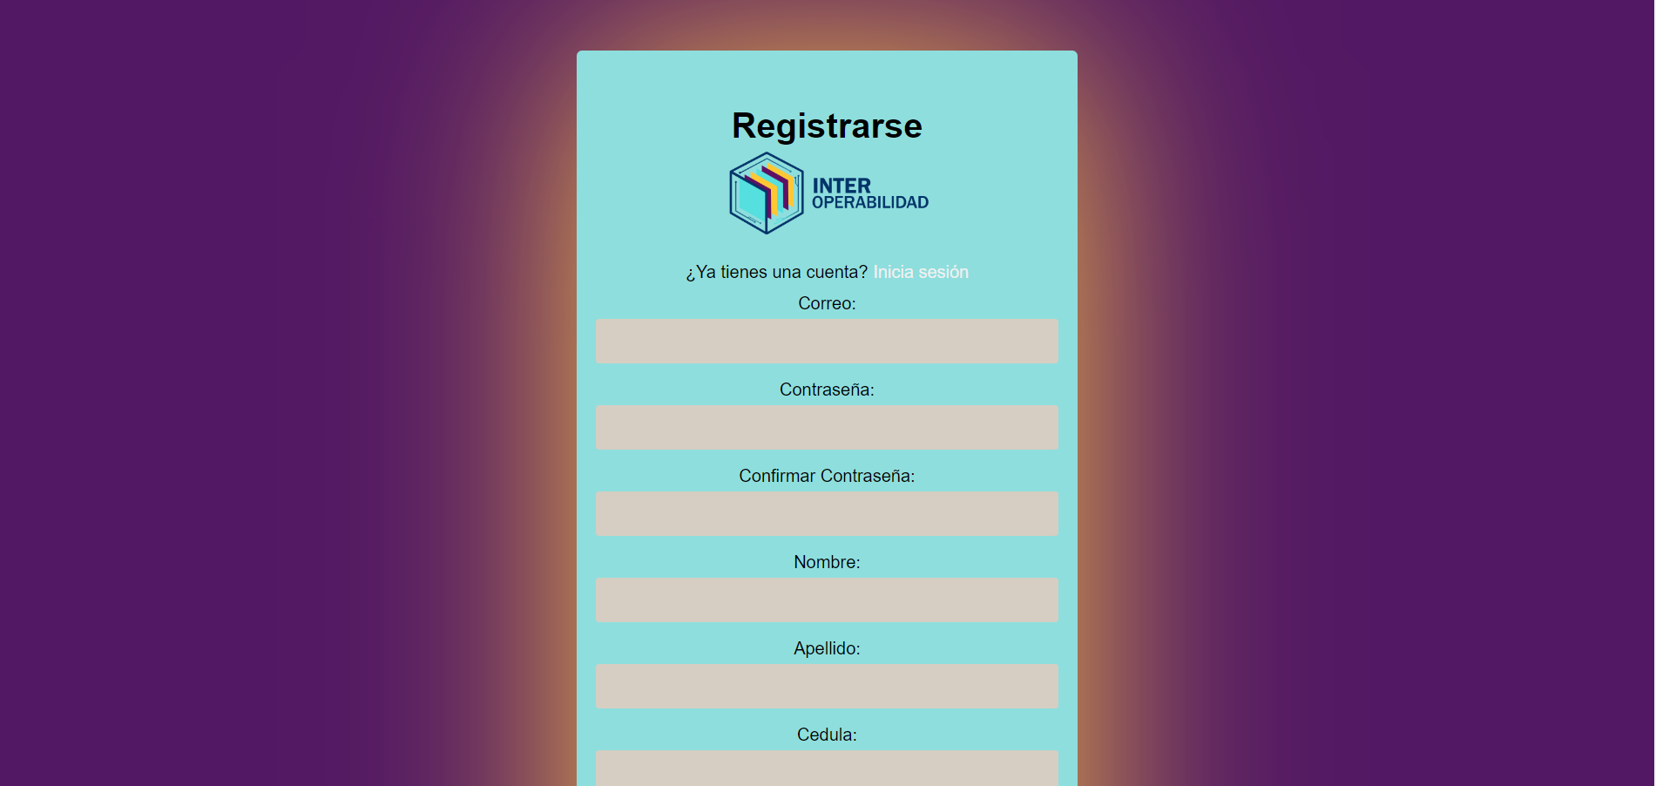

## Log in

Once the new user has registered, they can go to the home page in order to use the information services and view the documents that are useful to them.

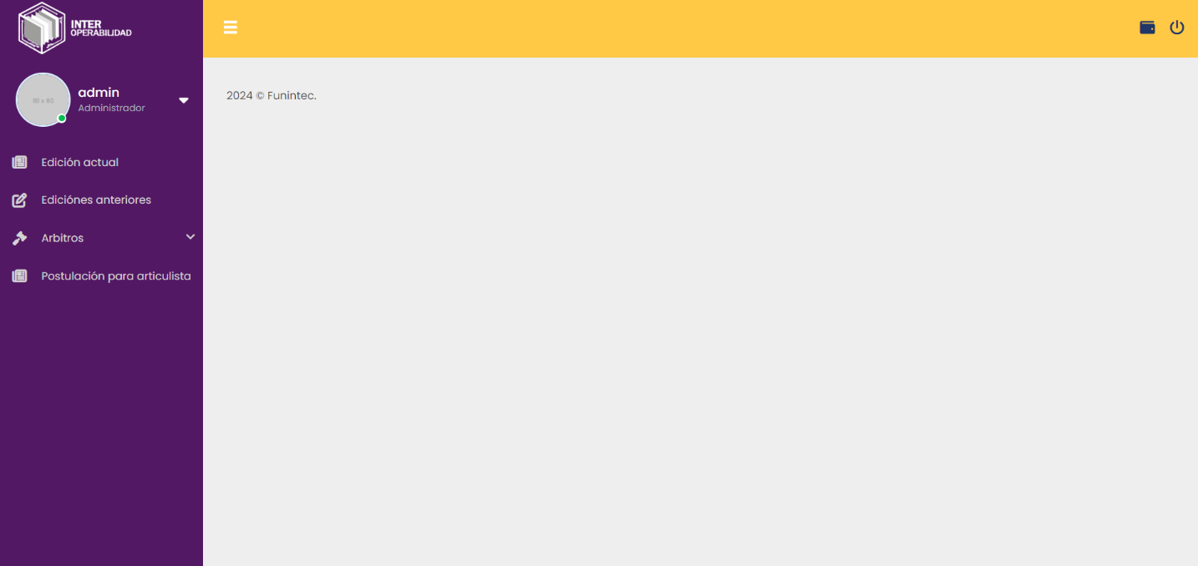

On the page the user can carry out the following activities:

5.1- Add or modify the user's profile

a- Profile

b- Setting

c- Log out

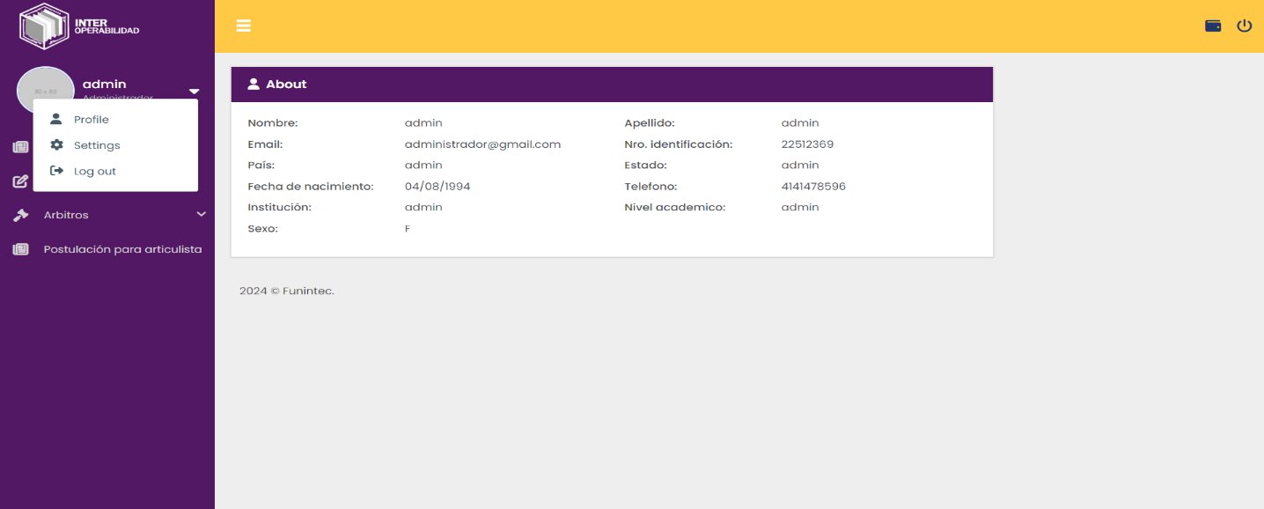

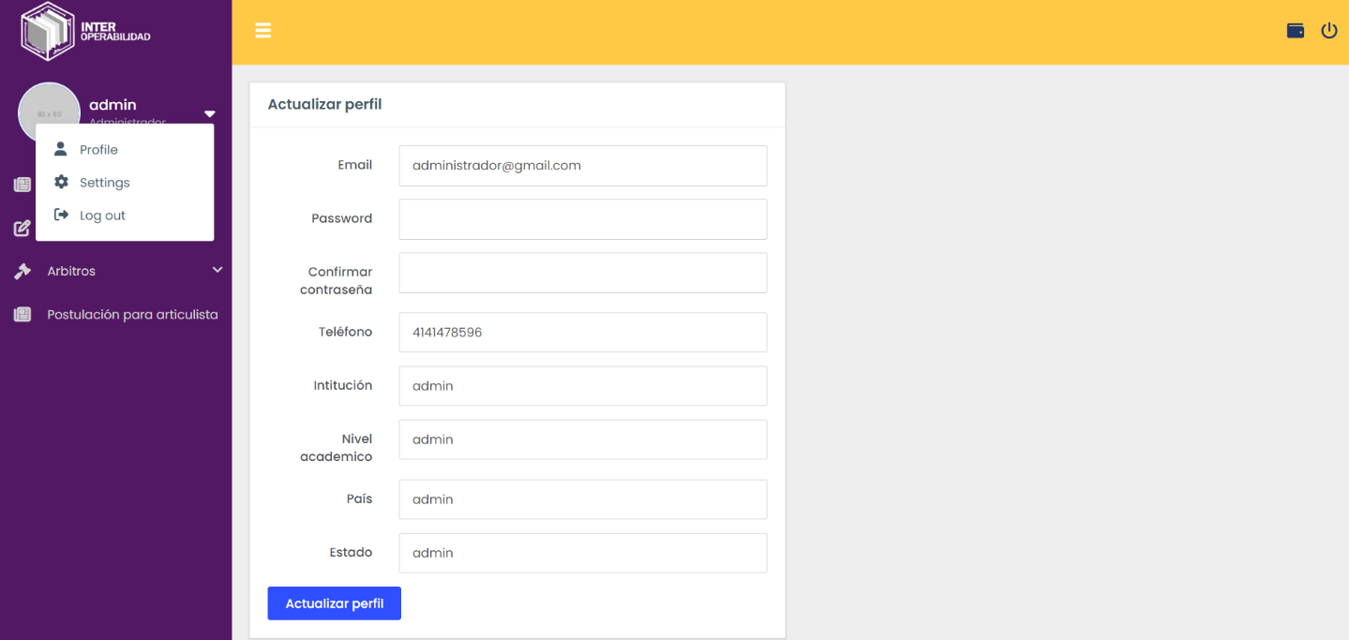

5.2- See the current editions and previous editions of the scientific journal

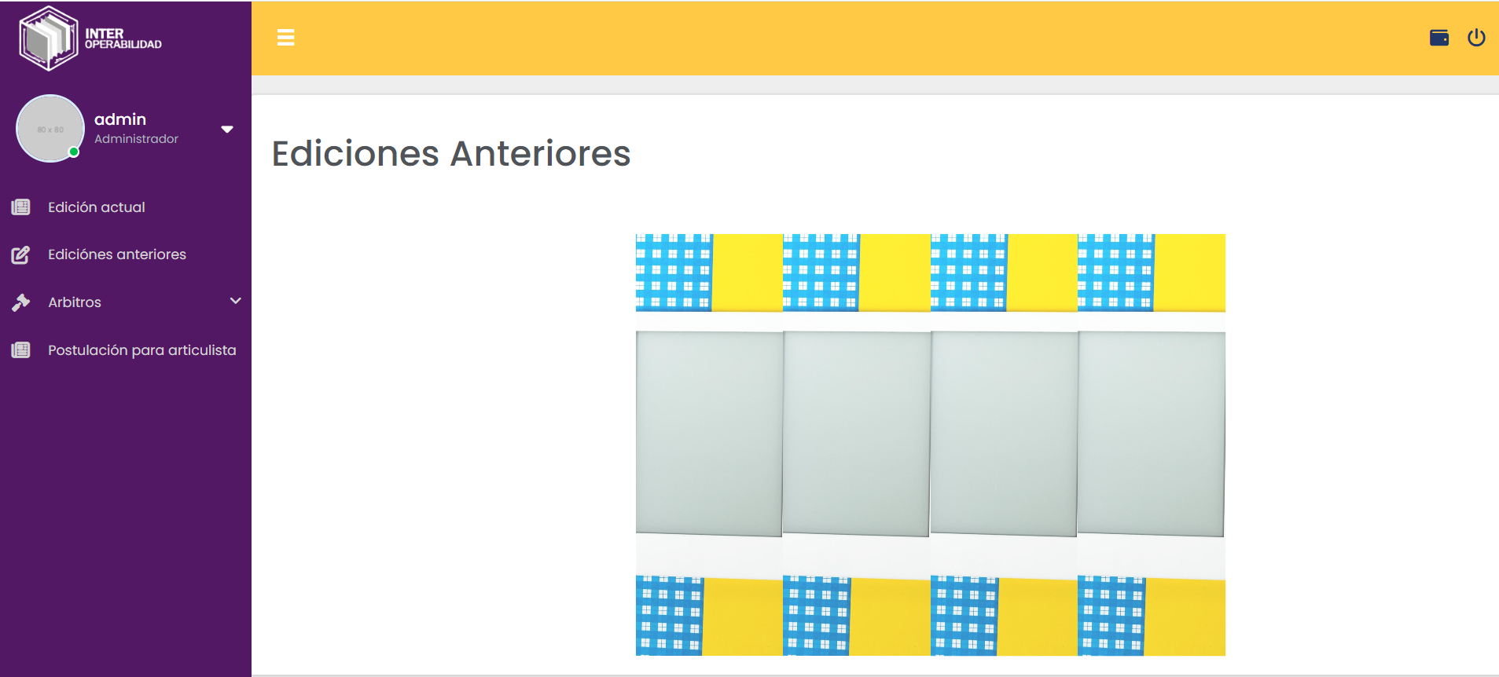

5.4- See the portfolio of referees and referees by edition

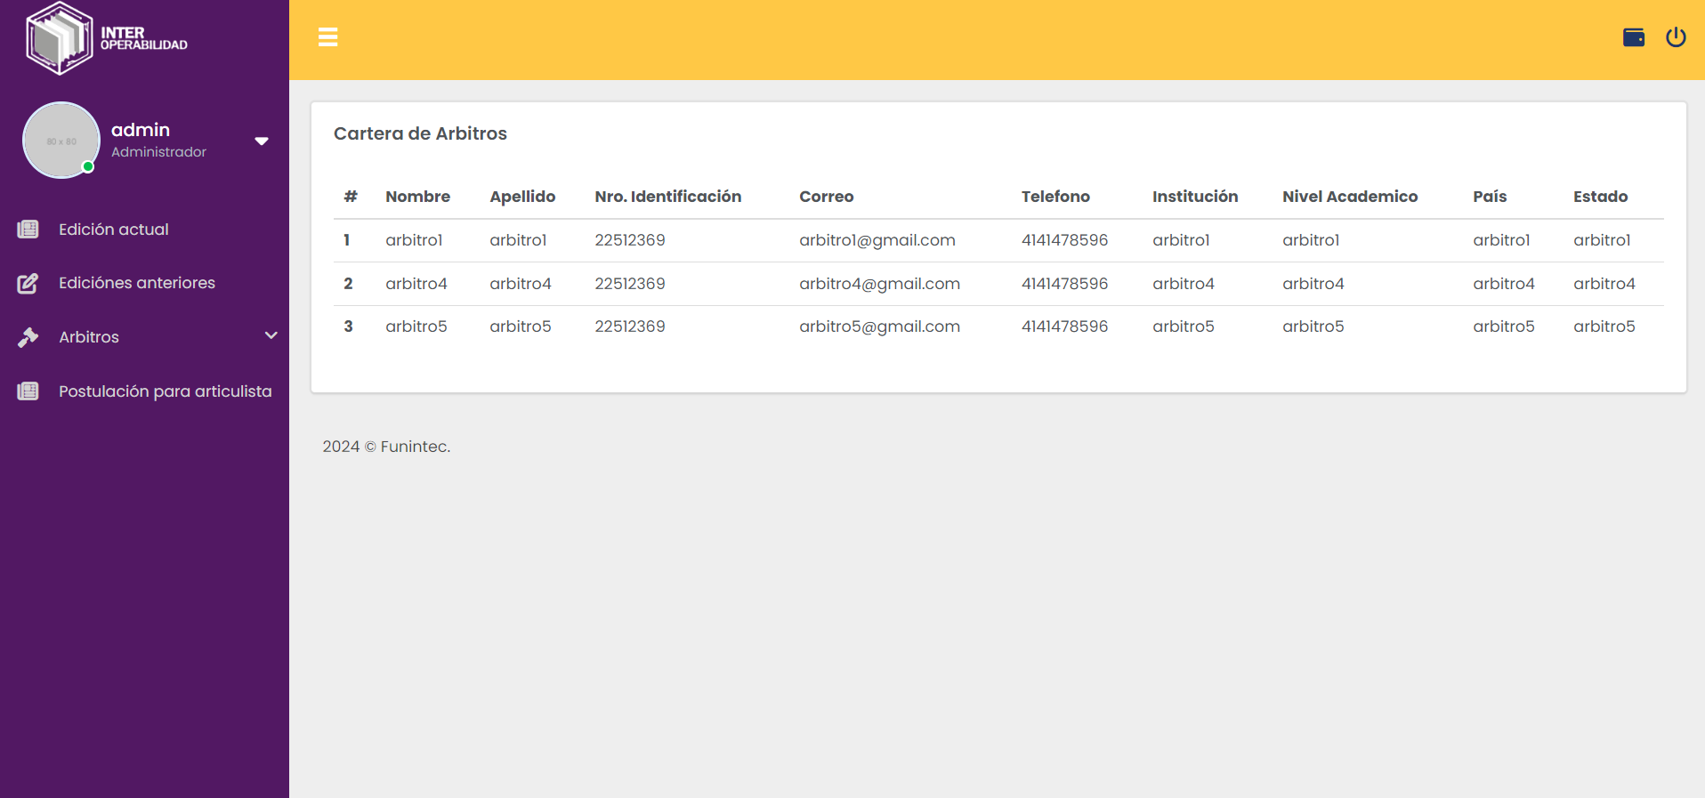

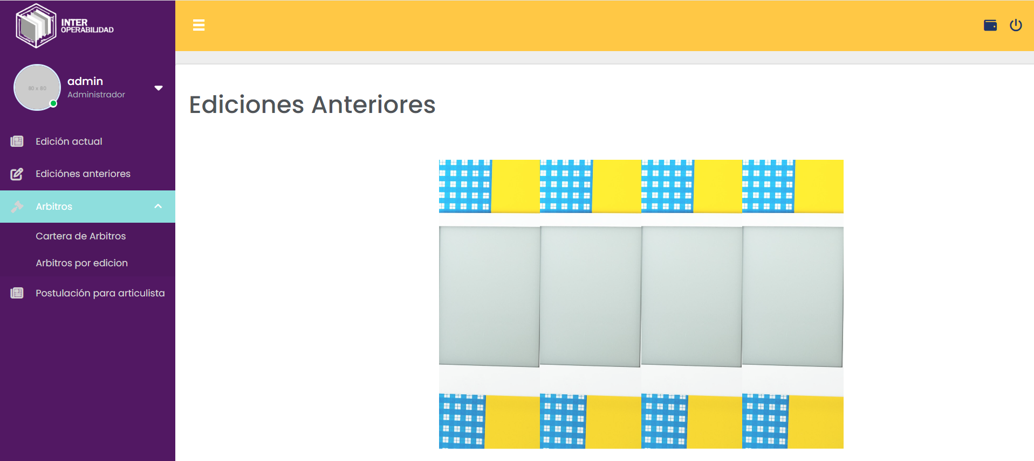

5.5- Be able to apply as a columnist for the scientific journal

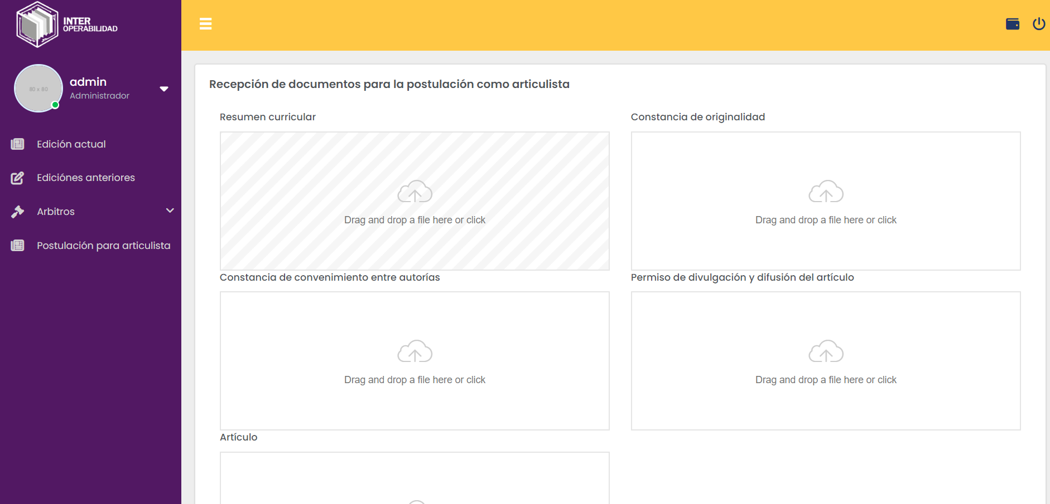

All images show the functionality of the portal development and how it is currently operational.

In the next stage, the registration of users will begin to upload selected articles for the magazine according to what is planned and the registration of the referees who will evaluate the works.

This report is presented as evidence of the progress and achievements achieved and demonstrable

This information is accompanied by a demonstration video

Hoping that this information is relevant and useful.